

NFHS Data Analysis for Regional IFA Tablet Consumption

Name: Savani Sanjay Burgute (23M2502)

Self Project (July-August 2024)

# NFHS Data Analysis for Regional IFA Tablet Consumption

# **Project Duration:** July 2024 - August 2024

# **Project Type:** Self Project

# **Project Overview:**

# This project involves the analysis of National Family Health Survey (NFHS) data to examine the regional consumption patterns of Iron and Folic Acid (IFA) tablets by pregnant women, specifically focusing on those who consumed the tablets for 180 days or more. The goal was to identify patterns and regional disparities in IFA tablet consumption.

# **Key Features:**

# ETL & EDA: Extracted, transformed, and loaded (ETL) NFHS data, followed by extensive Exploratory Data Analysis (EDA) to gain insights into IFA tablet consumption across different regions.

# Spatial Analysis: Conducted Local Indicators of Spatial Association (LISA) Analysis using GeoDA to identify Hot Spots (areas with high consumption) and Cold Spots (areas with low consumption) of IFA tablet use.

# Statistical Analysis: Employed Stata for advanced statistical analysis to delve deeper into the data, while Excel was used for initial data cleaning and preliminary analysis.

# **Highlights:**

# Identification of Regional Patterns: The LISA analysis revealed significant regional patterns, helping to pinpoint areas that require more attention for IFA supplementation programs.

# **Conclusion:**

# The project successfully highlighted regional disparities in IFA tablet consumption among pregnant women, providing valuable insights for public health interventions and policy formulation.

# NFHS Data Analysis for Regional IFA Tablet Consumption

**Introduction**

Maternal health is a crucial aspect of public health, representing the overall welfare of not just mothers but the entire community. Pregnancy necessitates careful attention to guarantee the optimal well-being of both the expectant woman and her unborn child. The ingestion of Iron and Folic Acid (IFA) pills plays a crucial role in maternal care in this context. It considerably helps prevent anemia and promotes a healthy gestational period. The significant influence of maternal health on the wider socioeconomic structure cannot be exaggerated. An optimal maternal experience is directly linked to higher rates of child survival, decreased likelihood of birthing problems, and increased chances for the general development of the offspring. Within the complex realm of maternal health, the use of IFA tablets emerges as a cost-efficient and influential intervention.

Iron and Folic Acid, when administered in the proper dosages, are essential for resolving nutritional deficiencies that are frequently linked to pregnancy. Anemia, a common issue among pregnant women, can result in negative consequences such as reduced birth weight, premature birth, and maternal death. According to the Guidelines for Control of Iron Deficiency Anaemia, it has been recommended that taking IFA pills regularly for over 180 days during pregnancy is a strategic preventative step to protect the health of both the mother and the child.

As we examine the field of maternal health, it is crucial to investigate and comprehend the local variations that impact the adoption of IFA tablets. By analyzing the National Family Health Survey (NFHS) data based on NSSO natural areas, we may reveal patterns, discrepancies, and trends that provide valuable insights for implementing specific policy interventions. This policy brief aims to clarify the complexities involved and provide insight into using IFA tablets as a significant measure and driving force for enhancing maternal health outcomes in various geographical and socio-economic contexts.

# Data and Methodology

The study utilizes data from NFHS-4 (2015-16) and NFHS-5 (2019-20), focusing on the consumption of IFA tablets by pregnant women for an optimal duration of more than 180 days. NSSO natural regions, known for their homogeneity in terms of socio-economic and geographical characteristics, are employed to categorize the data. Also, the decision to choose NSSO regions for analyzing the consumption of IFA tablets by pregnant women is justified by their ability to reveal patterns that transcend state boundaries and showcase significant intra-regional differences. NSSO regions provide a holistic perspective by cutting across administrative divisions, allowing us to uncover broad trends in maternal health that may go unnoticed at state level. Furthermore, there is significant variety within each NSSO zone, allowing for a detailed investigation of localized factors impacting pregnant women's usage of IFA pills. This simultaneous focus on overarching patterns and intra-regional variances improves the precision of our analysis and allows for tailored responses based on region-specific needs. The methodology involves a comparative

analysis of the prevalence of adequate IFA consumption across NSSO natural regions, highlighting changes and trends between the two survey rounds.

For example, during NFHS-4, it can be seen in Figure 1 that Tamil Nadu and Kerala were the best- performing states and during NFHS-5, states like Punjab, Himachal Pradesh, Andhra Pradesh, Tamil Nadu, Kerala, and Gujarat were performing better but analyzing it through NSSO regions will help us to understand which regions within the state are performing well and which are required special attention. It will ultimately help to implement various policy-level decisions.

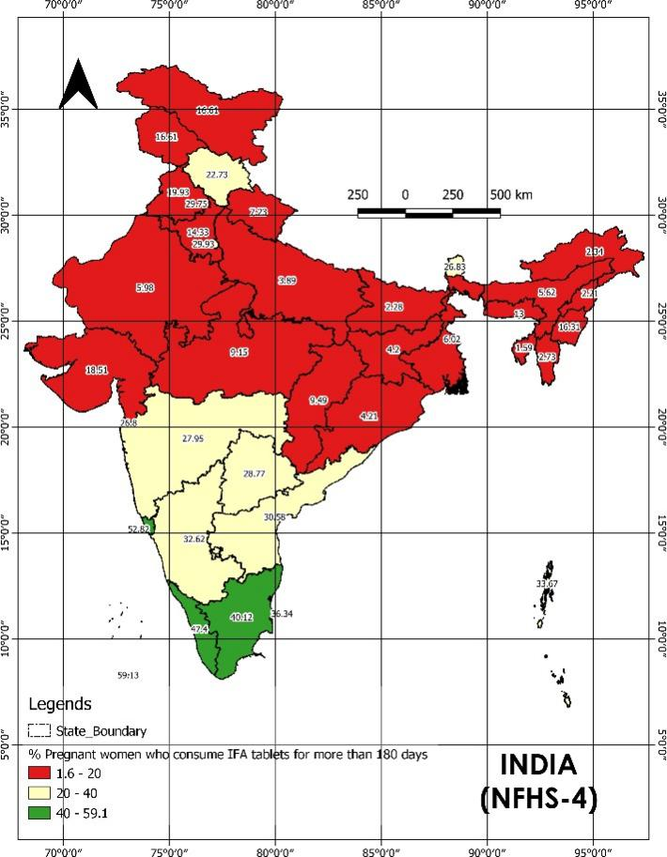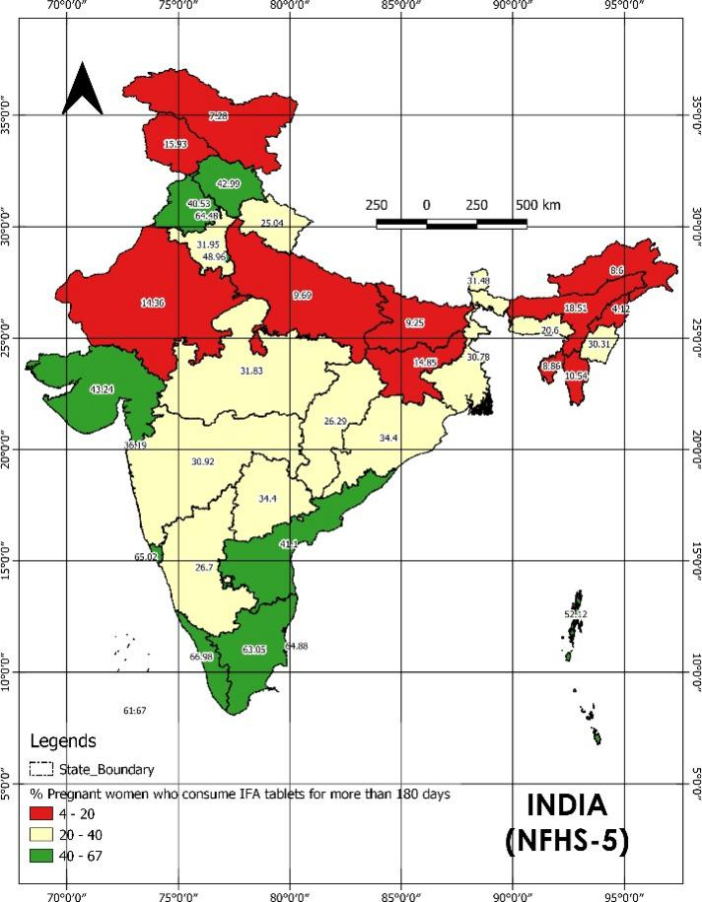

***Figure 1:*** *% Pregnant women who consume IFA tablets for more than 180 days (State Boundary)*

# Key Findings

From the maps shown in Figure 2, it is visible that there has been significant progress over the years in the NSSO regions lying in the state of Madhya Pradesh, Tamil Nadu, Andhra Pradesh, Orissa, Gujarat, Himachal Pradesh Uttarakhand, West Bengal, Meghalaya, and Assam whereas a decline can be seen in a few regions of Maharashtra.

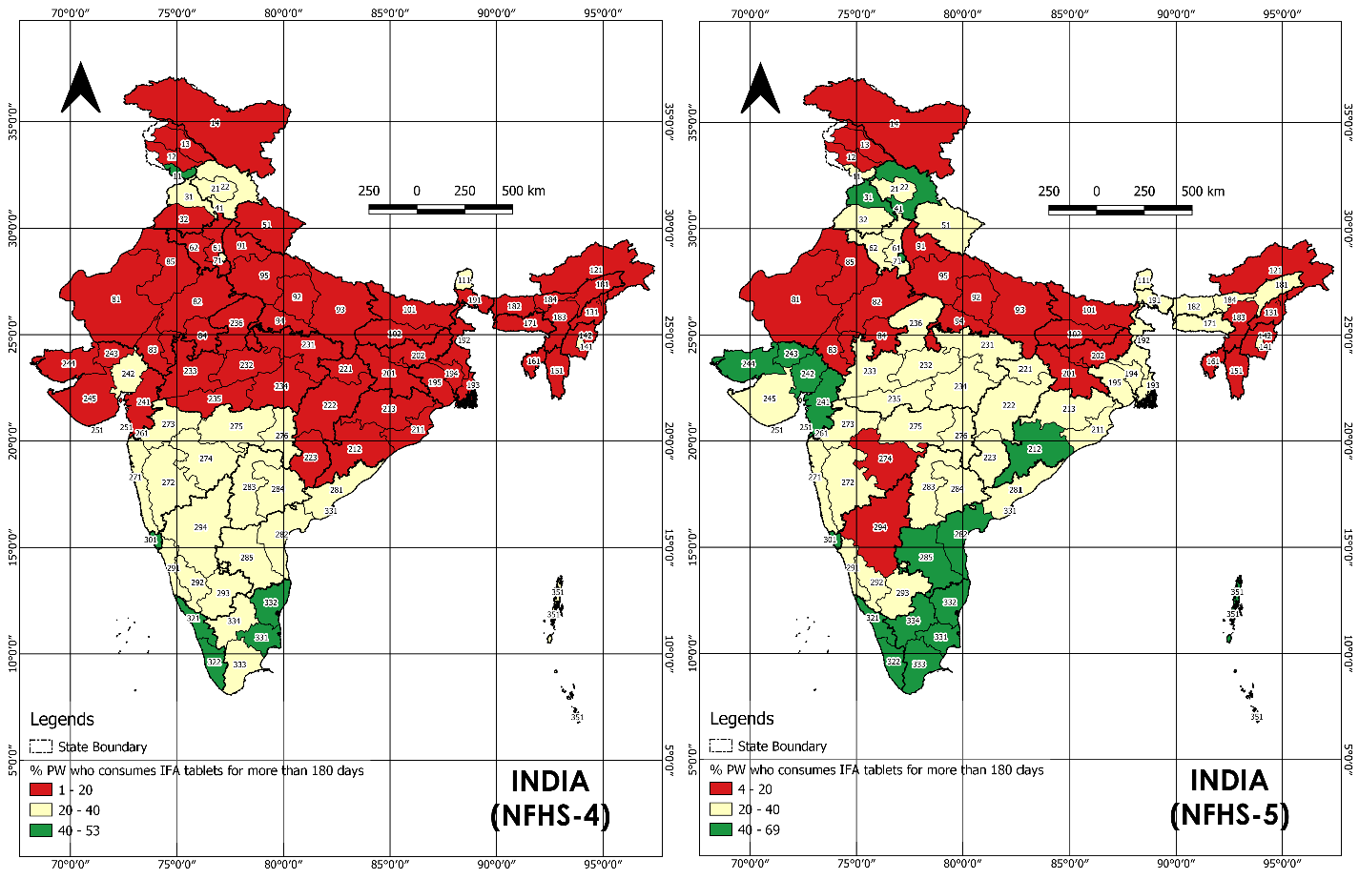

***Figure 2****: % Pregnant women who consume IFA tablets for more than 180 days (NSSO Regions)*

Iron-Folic Acid (IFA) tablets stand as crucial supplements for pregnant women in India, serving to prevent anemia and promote proper fetal development. Despite the well-established advantages of these tablets, attaining the ideal level of consumption remains a persistent challenge. Several governmental initiatives have played a pivotal role in fostering an encouraging surge in the consumption of Iron-Folic Acid (IFA) tablets by pregnant women, as evidenced by data from NFHS-4 and NFHS-5 across diverse NSSO regions. These initiatives have strategically addressed awareness, accessibility, and adherence, resulting in positive and discernible outcomes. The National Iron Plus Initiative (NIPI) and the Anemia Mukt Bharat (AMB) program have emerged as key contributors, playing crucial roles in furnishing free IFA tablets and amplifying awareness through Information, Education, and Communication (IEC) campaigns. The integration of mobile health solutions, such as M-Mitra and ANMOL, has facilitated personalized information dissemination and improved communication channels with healthcare providers, contributing significantly to enhanced adherence.

In tandem, community-based interventions, involving Accredited Social Health Activists (ASHAs) and local leaders, have played a vital role. These interventions encompass doorstep delivery, culturally sensitive awareness campaigns, and the navigation of cultural barriers. Collaborative efforts with non-governmental organizations (NGOs) and private entities have expanded the reach of IFA tablets, particularly in underserved communities. While these endeavors have yielded positive outcomes, certain NSSO regions have experienced a decline in IFA tablet consumption, emphasizing the need for thorough analysis to discern specific challenges unique to these areas. Factors such as lack of awareness, accessibility issues,

cultural barriers, and concerns about potential side effects may contribute to this observed decline. Identifying and addressing these nuanced challenges is imperative for sustaining and expanding the positive trajectory of IFA tablet consumption across diverse regions.

From the box plot and connected diagram analysis, it can be concluded that during the tenure of NFHS-4, 50% of the NSSO regions were those regions where the pregnant women who were consuming IFA tablets were less than 12% which has seen an increase during NFHS-5. In NFHS-5, the no. has increased to 33% i.e, 50% of the NSSO regions had approx. 33% of pregnant women who were consuming IFA tablets. The data also shows a few of the NSSO regions which have shown negative progress which is a matter of concern. These regions were 11(Mountainous region of Jammu & Kashmir), 273(Inland Northern region of Maharashtra), and 294(Inland Northern region of Karnataka) which have seen a major decline and the NSSO regions 12(Outer Hills region of J&K), 14(Ladakh), 274(Inland Central region of Maharashtra), and 293(Inland Southern region of Karnataka) have seen a slight decline. The best growth has been observed in the NSSO regions 41, 191-195, 212, 221, 233-235, 241, 243, 244, and the best-performing regions were from the states of Goa, Tamil Nadu, Lakshadweep, Kerala, Andaman & Nicobar Island, and Puducherry.

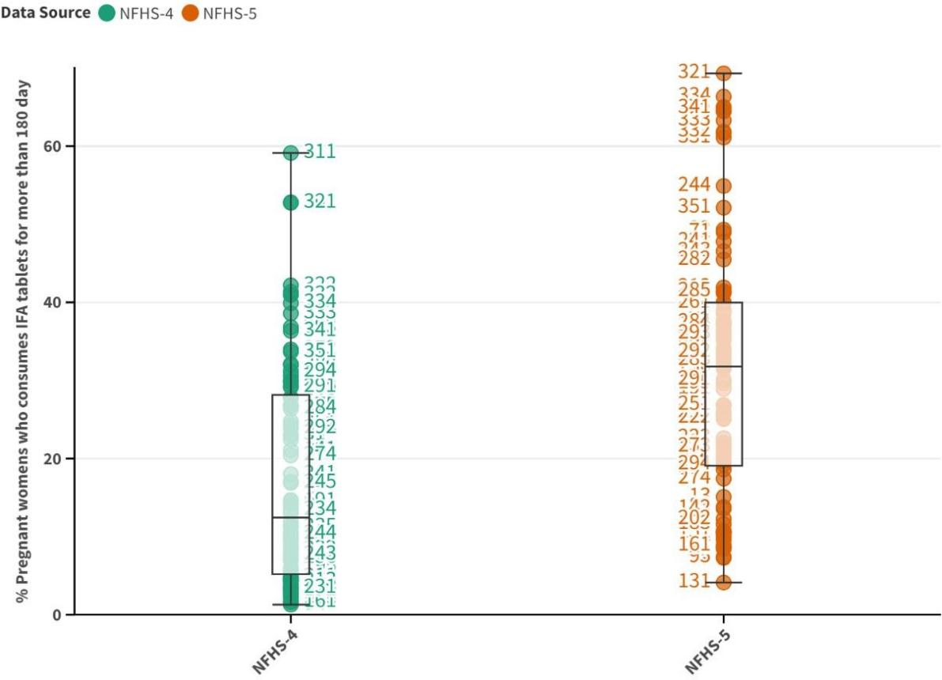

***Figure 3:*** *Box plot analysis of % Pregnant women who consume IFA tablets for more than 180 day*

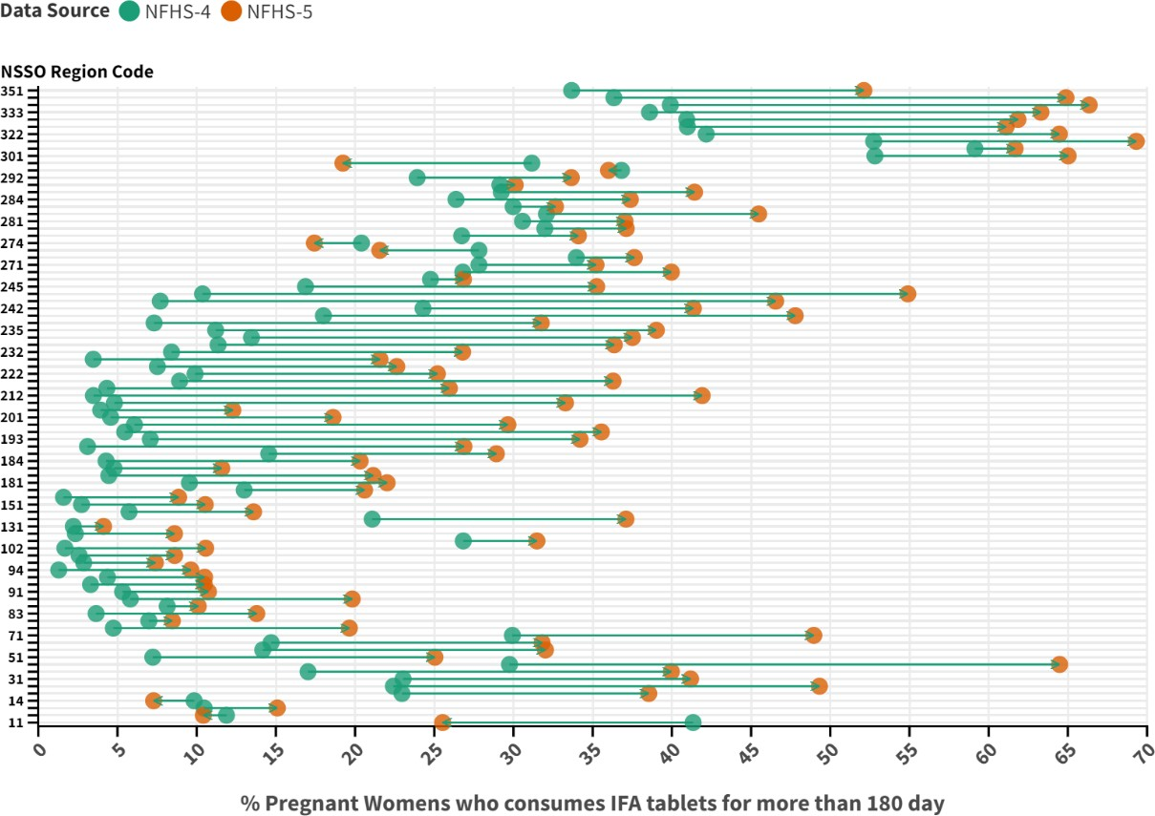

***Figure 4:*** *Connected diagram analysis of % Pregnant women who consume IFA tablets for more than 180 day*

# LISA Analysis:

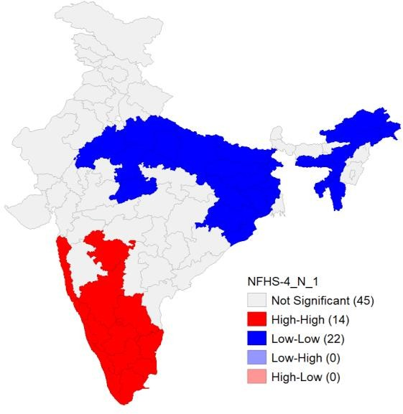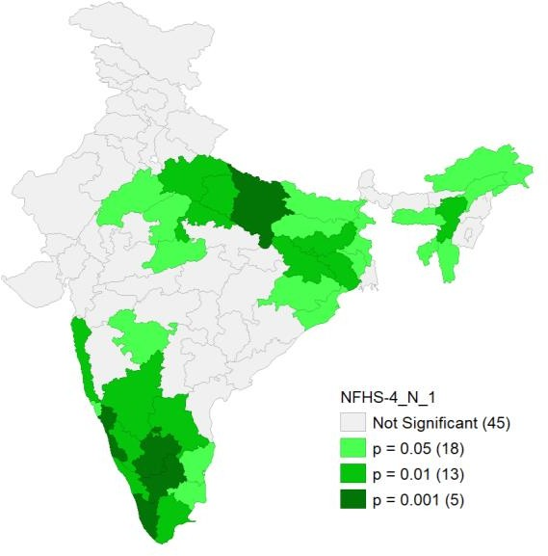

***Figure 5:*** *LISA Cluster Map & Significance Map (NFHS-4)*

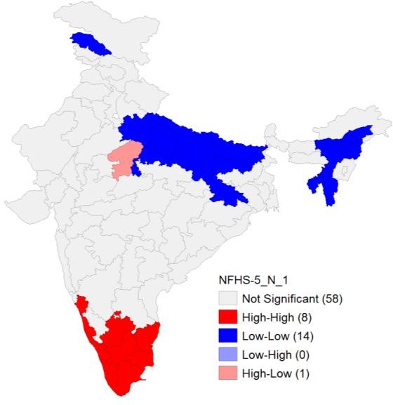 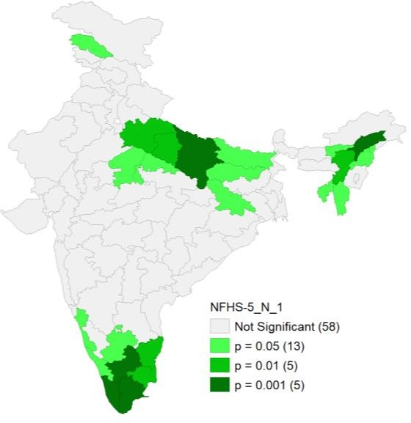

***Figure 6:*** *LISA Cluster Map & Significance Map (NFHS-5)*

From the Local Indicator of Spatial Association (LISA) analysis, it can be observed that during NFHS-4, 14 NSSO regions have been identified which show a higher percentage of pregnant women who are consuming IFA tablets and surrounded by NSSO regions which also have a higher percentage of pregnant women who are consuming IFA tablets. These regions mainly lie in the states of Tamil Nadu, Kerala, Goa, and Karnataka, and the influence can be observed in the NSSO regions 271 and 274 of Maharashtra, and 285 (Andhra Pradesh). There are 22 regions identified which show a lower percentage of pregnant women who are consuming IFA tablets and surrounded by NSSO regions which also have a lower percentage of pregnant women who are consuming IFA tablets. These regions mainly lie in the states of Uttar Pradesh, Bihar, Jharkhand, and in the northeastern states like Assam, Arunachal Pradesh, Meghalaya, and Tripura. The influence can be observed in the neighboring NSSO regions like 256 and 232 of Madhya Pradesh, 82(Rajasthan), and 211 & 213 of Orrisa.

In NFHS-5, 8 NSSO regions have been identified which show a higher percentage of pregnant women who are consuming IFA tablets, and surrounded by NSSO regions which also have a higher percentage of pregnant women who are consuming IFA tablets. These regions mainly lie in the states of Tamil Nadu and Kerala, and the influence can be observed in the NSSO region 291(Karnataka) and 293(Andhra Pradesh). There are 14 regions identified which show a lower percentage of pregnant women who are consuming IFA tablets and surrounded by NSSO regions which also have a lower percentage of pregnant women who are consuming IFA tablets. These regions mainly lie in the states of Uttar Pradesh, Jammu & Kashmir(13), Mizoram, Tripura, and Nagaland, and the influence can be seen in the NSSO region 181, 183, 184 of Assam, 202 of Jharkhand. In the NSSO region 236 of Madhya Pradesh, there is a higher percentage of pregnant women who are consuming IFA tablets, and surrounded by NSSO regions which also have a lower percentage of pregnant women who are consuming IFA tablets.

# Policy Recommendation

1. **Enhancing Health Literacy Initiatives:** Implement robust health literacy campaigns across urban and rural settings to increase awareness regarding the crucial role of IFA tablet consumption during pregnancy. Utilize diverse channels, including community health workers, educational institutions, and digital platforms, to disseminate information on how IFA tablets mitigate anemia risks and contribute to healthy fetal development.
2. **Empowering ASHAs and Local Leaders for Community Outreach:** Strengthen the involvement of Accredited Social Health Activists (ASHAs) and local community leaders in advocating for IFA tablet consumption. Conduct regular community-focused awareness sessions, leveraging the influence of respected community figures to convey the importance of consistent IFA supplementation. Facilitate the seamless delivery of IFA tablets through these community networks, addressing logistical challenges.
3. **Seamless Integration into Maternal Healthcare Services:** Integrate the distribution of IFA tablets seamlessly into existing maternal healthcare services. Ensure that healthcare providers routinely prescribe and dispense IFA tablets during antenatal care(ANC) visits. Establish effective monitoring mechanisms to track and incentivize healthcare providers for adhering to IFA prescription guidelines. Forge strong collaborations with private healthcare providers to guarantee a steady supply of IFA tablets, reinforcing their role in championing maternal health.

# Annexures:

**NFHS-4 Data: % Pregnant women who consume IFA tablets for more than 180 day**

|  |  |  |  |
| --- | --- | --- | --- |
| **NSSO**  **Code** | **NSSO region** | **State** | **% PW who consumes IFA tablets for more**  **than 180 day** |
| 11 | Mountainous | Jammu and Kashmir | 41.34 |
| 12 | Outer Hills | Jammu and Kashmir | 11.88 |
| 13 | Jhelam Valley | Jammu and Kashmir | 10.47 |
| 14 | Ladakh | Leh(Ladakh) | 9.84 |
| 21 | Central | Himachal Pradesh | 22.96 |
| 22 | Trans Himalayan & Southern | Himachal Pradesh | 22.42 |
| 31 | Northern | Punjab | 23.03 |
| 32 | Southern | Punjab | 17.03 |
| 41 | Chandigarh | Chandigarh | 29.75 |
| 51 | Uttarakhand | Uttarakhand | 7.23 |
| 61 | Eastern | Haryana | 14.17 |
| 62 | Western | Haryana | 14.7 |
| 71 | Delhi | Delhi | 29.93 |
| 81 | Western | Rajasthan | 4.74 |
| 82 | Northeastern | Rajasthan | 6.98 |
| 83 | Southern | Rajasthan | 3.65 |
| 84 | Southeastern | Rajasthan | 8.14 |
| 85 | Northern | Uttar Pradesh | 5.81 |
| 91 | Northern Upper Ganga Plains | Rajasthan | 5.32 |
| 92 | Central | Uttar Pradesh | 3.3 |
| 93 | Eastern | Uttar Pradesh | 4.37 |
| 94 | Southern | Uttar Pradesh | 1.29 |
| 95 | Southern Upper Ganga Plains | Uttar Pradesh | 2.87 |
| 101 | Northern | Bihar | 2.58 |
| 102 | Central | Bihar | 1.68 |
| 111 | Sikkim | Sikkim | 26.83 |
| 121 | Arunachal Pradesh | Arunachal Pradesh | 2.34 |
| 131 | Nagaland | Nagaland | 2.21 |
| 141 | Plains | Manipur | 21.08 |
| 142 | Hills | Manipur | 5.73 |
| 151 | Mizoram | Mizoram | 2.73 |
| 161 | Tripura | Tripura | 1.59 |
| 171 | Meghalaya | Meghalaya | 13 |
| 181 | Plains Eastern | Assam | 9.54 |
| 182 | Plains Western | Assam | 4.45 |
| 183 | Cachar Plain | Assam | 4.78 |
| 184 | Central Brahamputra Plains | Assam | 4.28 |
| 191 | Himalayan | West Bengal | 14.55 |
| 192 | Eastern Plains | West Bengal | 3.11 |

|  |  |  |  |
| --- | --- | --- | --- |
| 193 | Southern Plains | West Bengal | 7.07 |
| 194 | Central Plains | West Bengal | 5.46 |
| 195 | Western Plains | West Bengal | 6.07 |
| 201 | Ranchi Plateau | Jharkhand | 4.57 |
| 202 | Hazaribagh Plateau | Jharkhand | 3.94 |
| 211 | Coastal | Odisha | 4.81 |
| 212 | Southern | Odisha | 3.48 |
| 213 | Northern | Odisha | 4.33 |
| 221 | Northern Chhattisgarh | Chhattisgarh | 8.92 |
| 222 | Mahanadi Basin | Chhattisgarh | 9.9 |
| 223 | Southern Chhattisgarh | Chhattisgarh | 7.52 |
| 231 | Vindhya | Madhya Pradesh | 3.47 |
| 232 | Central | Madhya Pradesh | 8.41 |
| 233 | Malwa | Madhya Pradesh | 11.35 |
| 234 | South | Madhya Pradesh | 13.46 |
| 235 | South Western | Madhya Pradesh | 11.2 |
| 236 | Northern | Madhya Pradesh | 7.31 |
| 241 | South Eastern | Gujarat | 18 |
| 242 | Plains Northern | Gujarat | 24.29 |
| 243 | Dry areas | Gujarat | 7.7 |
| 244 | Kachchh | Gujarat | 10.37 |
| 245 | Saurashtra | Gujarat | 16.87 |
| 251 | Daman & Diu | Daman & Diu | 24.76 |
| 261 | Dadra & Nagar Haveli | Dadra & Nagar Haveli | 26.8 |
| 271 | Coastal | Maharashtra | 27.82 |
| 272 | Inland Western | Maharashtra | 33.97 |
| 273 | Inland Northern | Maharashtra | 27.82 |
| 274 | Inland Central | Maharashtra | 20.4 |
| 275 | Inland Eastern | Maharashtra | 26.73 |
| 276 | Eastern | Maharashtra | 31.98 |
| 281 | Coastal Northern | Andhra Pradesh | 30.57 |
| 282 | Coastal Southern | Andhra Pradesh | 32.08 |
| 283 | Inland North Western | Telangana | 29.98 |
| 284 | Inland North Eastern | Telangana | 26.37 |
| 285 | Inland Southern | Andhra Pradesh | 29.23 |
| 291 | Coastal & Ghats | Karnataka | 29.14 |
| 292 | Inland Eastern | Karnataka | 23.92 |
| 293 | Inland Southern | Karnataka | 36.82 |
| 294 | Inland Northern | Karnataka | 31.16 |
| 301 | Goa | Goa | 52.82 |
| 311 | Lakshadweep | Lakshadweep | 59.13 |
| 321 | Northern | Kerala | 52.74 |
| 322 | Southern | Kerala | 42.17 |
| 331 | Coastal Northern | Tamil Nadu | 40.98 |
| 332 | Coastal | Tamil Nadu | 40.94 |

|  |  |  |  |
| --- | --- | --- | --- |
| 333 | Southern | Tamil Nadu | 38.59 |
| 334 | Inland | Tamil Nadu | 39.9 |
| 341 | Pondicherry | Puducherry | 36.34 |
| 351 | Andaman & Nicobar Islands | Andaman & Nicobar Islands | 33.67 |

# NFHS-5 Data: % Pregnant women who consume IFA tablets for more than 180 day

|  |  |  |  |
| --- | --- | --- | --- |
| **NSSO**  **Code** | **NSSO region** | **State** | **% PW who consumes IFA tablets for more**  **than 180 day** |
| 11 | Mountainous | Jammu and Kashmir | 25.53 |
| 12 | Outer Hills | Jammu and Kashmir | 10.42 |
| 13 | Jhelam Valley | Jammu and Kashmir | 15.09 |
| 14 | Ladakh | Leh(Ladakh) | 7.28 |
| 21 | Central | Himachal Pradesh | 38.54 |
| 22 | Trans Himalayan & Southern | Himachal Pradesh | 49.32 |
| 31 | Northern | Punjab | 41.18 |
| 32 | Southern | Punjab | 39.97 |
| 41 | Chandigarh | Chandigarh | 64.48 |
| 51 | Uttarakhand | Uttarakhand | 25.04 |
| 61 | Eastern | Haryana | 32.02 |
| 62 | Western | Haryana | 31.81 |
| 71 | Delhi | Delhi | 48.96 |
| 81 | Western | Rajasthan | 19.64 |
| 82 | Northeastern | Rajasthan | 8.46 |
| 83 | Southern | Rajasthan | 13.79 |
| 84 | Southeastern | Rajasthan | 10.1 |
| 85 | Northern | Uttar Pradesh | 19.82 |
| 91 | Northern Upper Ganga Plains | Rajasthan | 10.74 |
| 92 | Central | Uttar Pradesh | 10.48 |
| 93 | Eastern | Uttar Pradesh | 10.5 |
| 94 | Southern | Uttar Pradesh | 9.63 |
| 95 | Southern Upper Ganga Plains | Uttar Pradesh | 7.39 |
| 101 | Northern | Bihar | 8.61 |
| 102 | Central | Bihar | 10.57 |
| 111 | Sikkim | Sikkim | 31.48 |
| 121 | Arunachal Pradesh | Arunachal Pradesh | 8.6 |
| 131 | Nagaland | Nagaland | 4.12 |
| 141 | Plains | Manipur | 37.1 |
| 142 | Hills | Manipur | 13.59 |
| 151 | Mizoram | Mizoram | 10.54 |
| 161 | Tripura | Tripura | 8.86 |
| 171 | Meghalaya | Meghalaya | 20.6 |
| 181 | Plains Eastern | Assam | 22.02 |
| 182 | Plains Western | Assam | 21.14 |

|  |  |  |  |
| --- | --- | --- | --- |
| 183 | Cachar Plain | Assam | 11.58 |
| 184 | Central Brahamputra Plains | Assam | 20.32 |
| 191 | Himalayan | West Bengal | 28.92 |
| 192 | Eastern Plains | West Bengal | 26.87 |
| 193 | Southern Plains | West Bengal | 34.2 |
| 194 | Central Plains | West Bengal | 35.55 |
| 195 | Western Plains | West Bengal | 29.65 |
| 201 | Ranchi Plateau | Jharkhand | 18.61 |
| 202 | Hazaribagh Plateau | Jharkhand | 12.28 |
| 211 | Coastal | Odisha | 33.28 |
| 212 | Southern | Odisha | 41.91 |
| 213 | Northern | Odisha | 25.95 |
| 221 | Northern Chhattisgarh | Chhattisgarh | 36.29 |
| 222 | Mahanadi Basin | Chhattisgarh | 25.2 |
| 223 | Southern Chhattisgarh | Chhattisgarh | 22.63 |
| 231 | Vindhya | Madhya Pradesh | 21.57 |
| 232 | Central | Madhya Pradesh | 26.79 |
| 233 | Malwa | Madhya Pradesh | 36.36 |
| 234 | South | Madhya Pradesh | 37.51 |
| 235 | South Western | Madhya Pradesh | 39.02 |
| 236 | Northern | Madhya Pradesh | 31.75 |
| 241 | South Eastern | Gujarat | 47.79 |
| 242 | Plains Northern | Gujarat | 41.36 |
| 243 | Dry areas | Gujarat | 46.55 |
| 244 | Kachchh | Gujarat | 54.9 |
| 245 | Saurashtra | Gujarat | 35.25 |
| 251 | Daman & Diu | Daman & Diu | 26.84 |
| 261 | Dadra & Nagar Haveli | Dadra & Nagar Haveli | 39.97 |
| 271 | Coastal | Maharashtra | 35.21 |
| 272 | Inland Western | Maharashtra | 37.63 |
| 273 | Inland Northern | Maharashtra | 21.56 |
| 274 | Inland Central | Maharashtra | 17.43 |
| 275 | Inland Eastern | Maharashtra | 34.1 |
| 276 | Eastern | Maharashtra | 37.12 |
| 281 | Coastal Northern | Andhra Pradesh | 37.04 |
| 282 | Coastal Southern | Andhra Pradesh | 45.48 |
| 283 | Inland North Western | Telangana | 32.65 |
| 284 | Inland North Eastern | Telangana | 37.38 |
| 285 | Inland Southern | Andhra Pradesh | 41.43 |
| 291 | Coastal & Ghats | Karnataka | 30.11 |
| 292 | Inland Eastern | Karnataka | 33.65 |
| 293 | Inland Southern | Karnataka | 36 |
| 294 | Inland Northern | Karnataka | 19.23 |
| 301 | Goa | Goa | 65.02 |
| 311 | Lakshadweep | Lakshadweep | 61.67 |

|  |  |  |  |
| --- | --- | --- | --- |
| 321 | Northern | Kerala | 69.32 |
| 322 | Southern | Kerala | 64.46 |
| 331 | Coastal Northern | Tamil Nadu | 61.1 |
| 332 | Coastal | Tamil Nadu | 61.85 |
| 333 | Southern | Tamil Nadu | 63.3 |
| 334 | Inland | Tamil Nadu | 66.35 |
| 341 | Pondicherry | Puducherry | 64.88 |
| 351 | Andaman & Nicobar Islands | Andaman & Nicobar Islands | 52.12 |